**Operating System (MCA)**

**Date: - 11/08/2025**

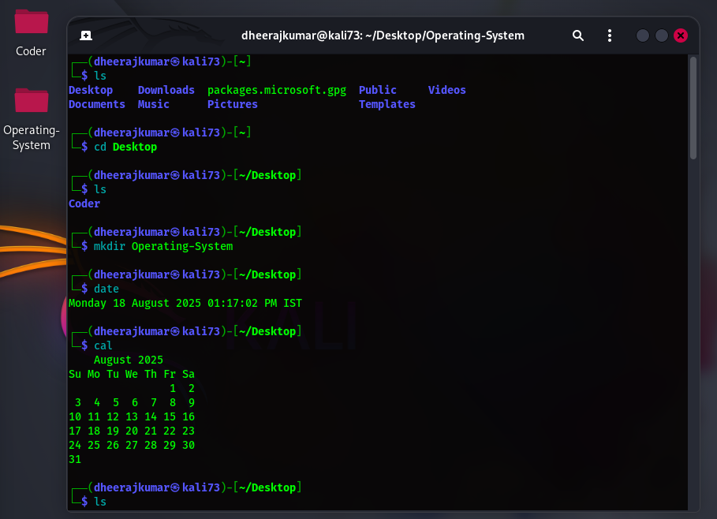

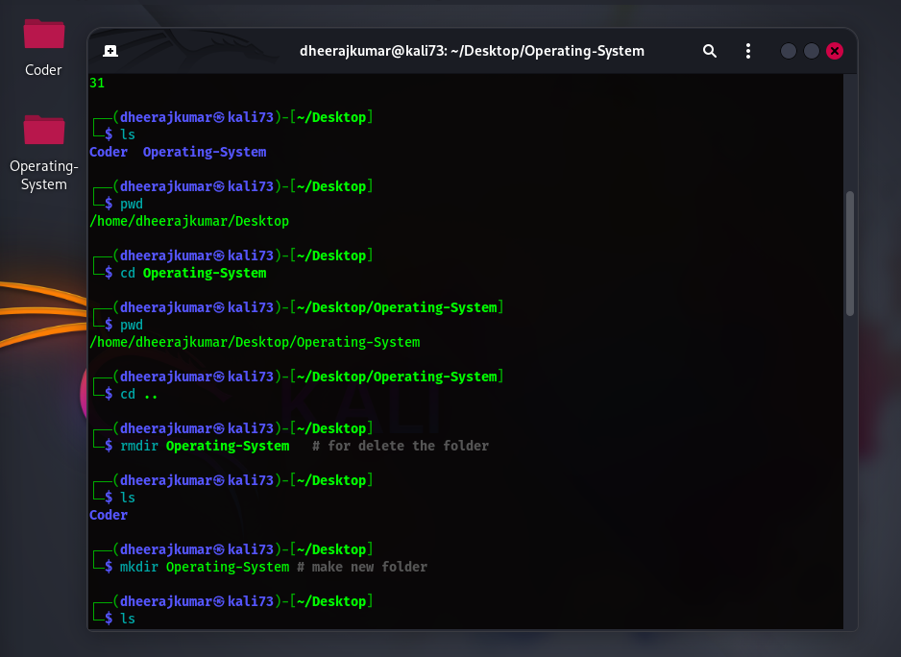

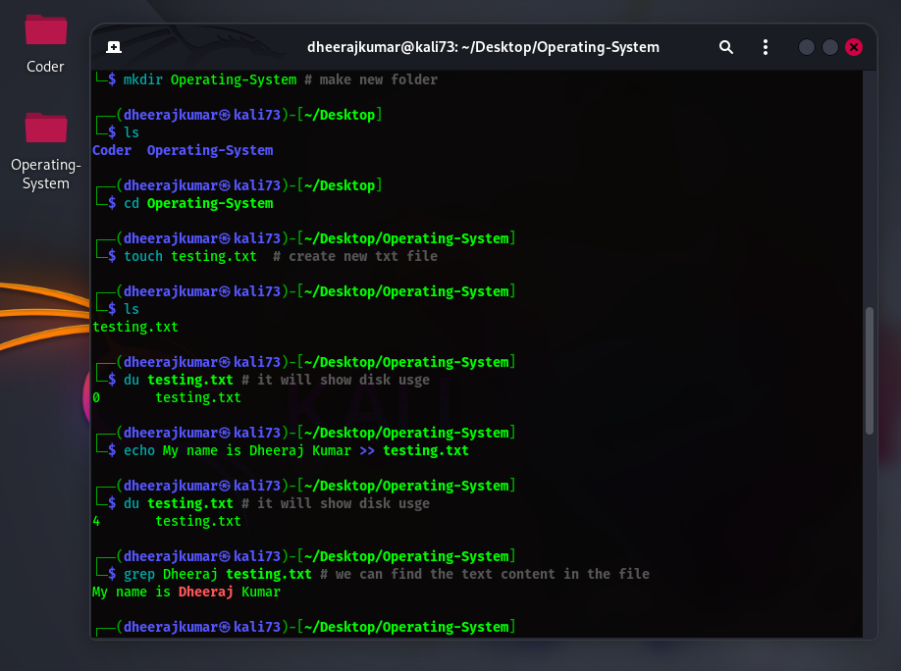

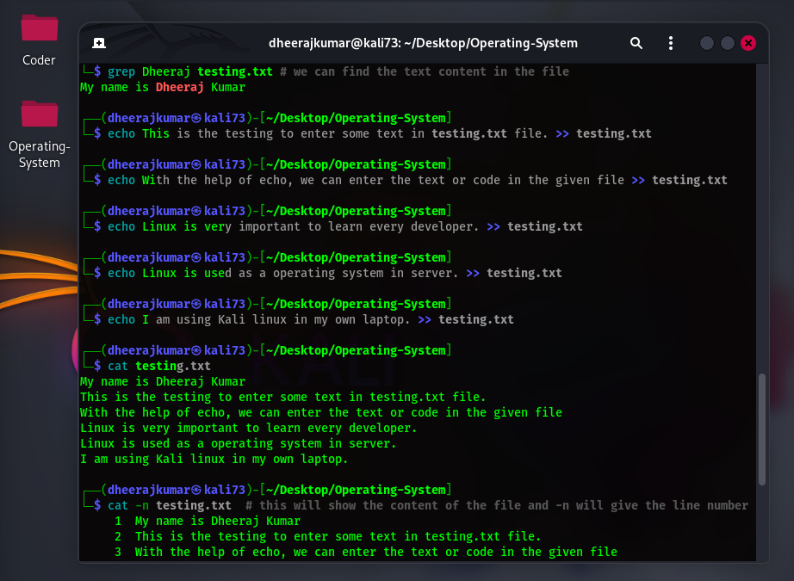

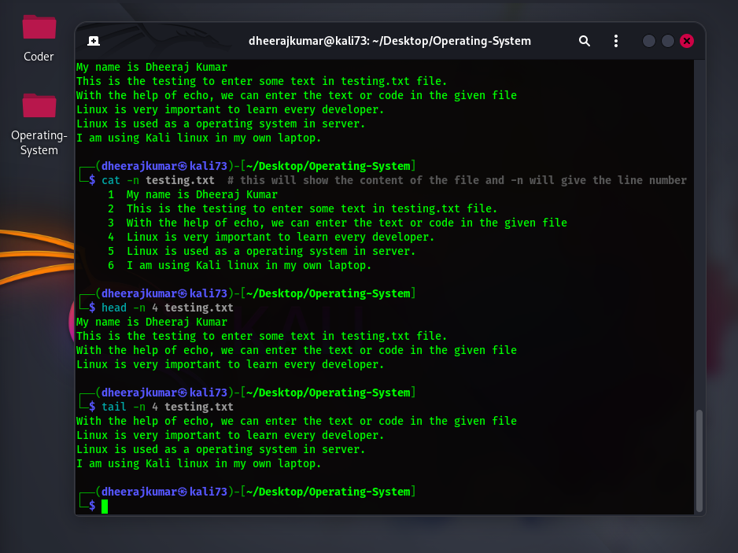

**Commands**

* **ls: -** List all the file and folder inside the path.
* **cd: -** Change directory.
* **cd .. : -** Change directory one step back
* **cd ~ :**- the command cd ~ is used to change the current working directory to the user's home directory. If you are currently in /usr/local/bin and you type cd ~, you will be returned to your home directory, which might be something like /home/your_username**.**
* **date: -** It will show the current date.
* **cal: -** It will show the calendar.
* **pwd: -** Present working directory.
* **mkdir: -** Make directory.
* **touch: -** Make file any of the type. For Example if you want to create testing.txt then write touch testing.txt
* **rmdir:** - Remove directory.
* **rm: -** Remove file
* **du:** - The du command in Linux is a powerful utility used to estimate and display the disk space usage of files and directories. It stands for "disk usage".
* **echo: -** The echo command is used to display a line of text. You can redirect its output to a file using the > or >> operators.

**echo "This text will overwrite the file." > filename.txt**

* **cat: -** The cat command in Linux is a versatile and fundamental command-line utility used for handling files. Its name, "cat", is short for "concatenate", reflecting its original purpose of combining files.

**Useful options**

The cat command offers several options to customize its behavior:

* -n or --number: Numbers all output lines.
* -b or --number-nonblank: Numbers only non-empty output lines.
* -s or --squeeze-blank: Suppresses multiple adjacent blank lines, replacing them with a single blank line.
* -E or --show-ends: Displays a dollar sign ($) at the end of each line, indicating line endings.
* -T or --show-tabs: Displays tab characters as ^I.
* -A or --show-all: Combines the functionality of -v, -E, and -T.
* -v or --show-nonprinting: Displays non-printing characters (except tabs and newlines) using ^ and M- notation
* **head: -** The head command in Linux is a command-line utility used to display the first few lines of one or more text files. It's useful for quickly inspecting the contents of a large file or the output of a command.

head -n 5 filename.txt # Displays the first 5 lines

head -c 20 filename.txt # Displays the first 20 bytes

**Useful options**

* -n <number>: Specifies the number of lines.
* -c <number>: Specifies the number of bytes.
* -q or --quiet: Suppresses the filename header for multiple files.
* -v or --verbose: Always displays the filename header.
* **tail: -** The tail command in Linux is a command-line utility used to display the last part of a file or files. By default, it shows the last 10 lines of the input. It's essentially the inverse of the head command, which shows the beginning lines of a file.

tail filename.txt

This command outputs the last 10 lines of filename.txt to your terminal.

* tail -n 4 filename.txt: - This will show bottom 4 line of content.

# Q1. Write sell script for creating a variable.

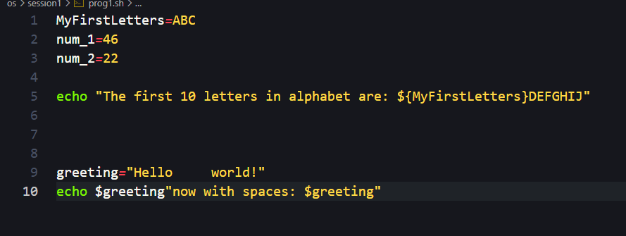

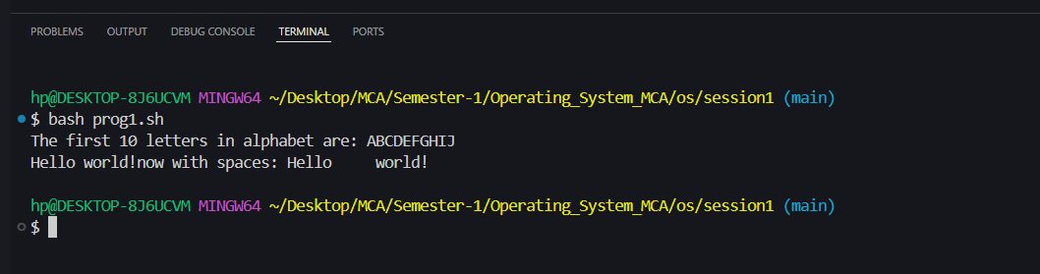

# Q2. Write shell script to add two number.

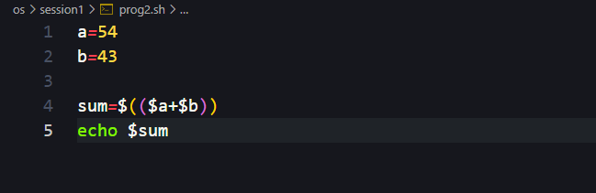

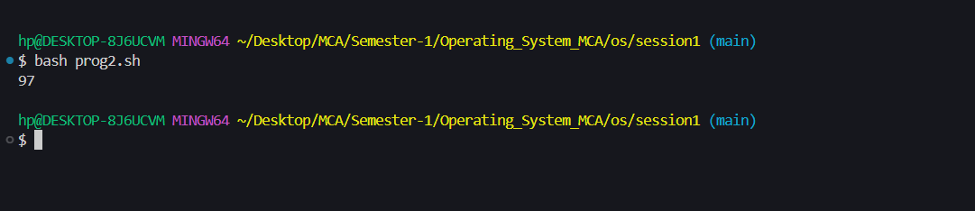

# Q3. Write shell script to demonstrate the case structure.

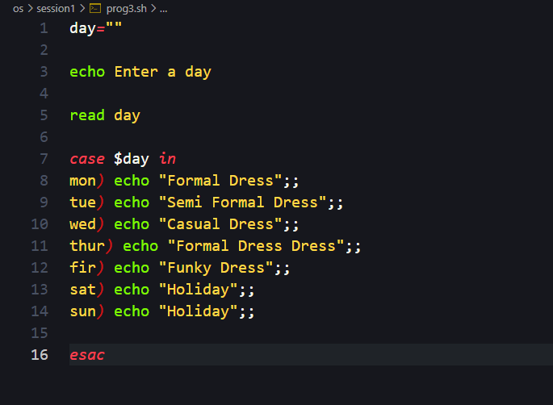

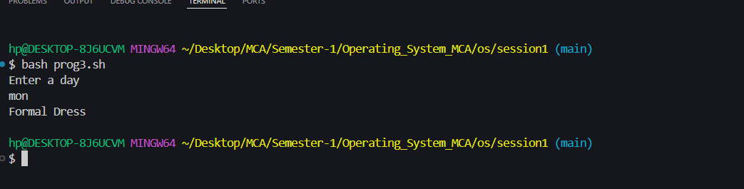

# Q4. Write shell script to check two number are equal or not.

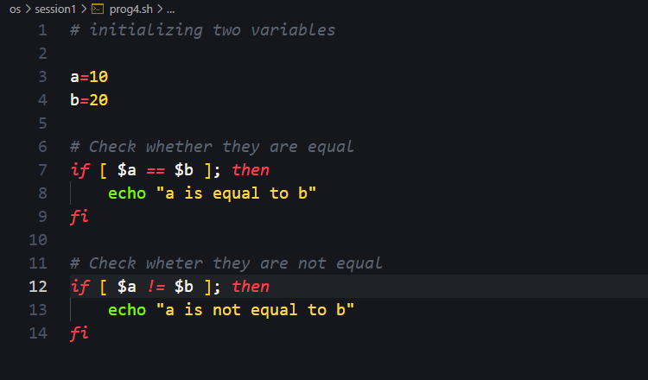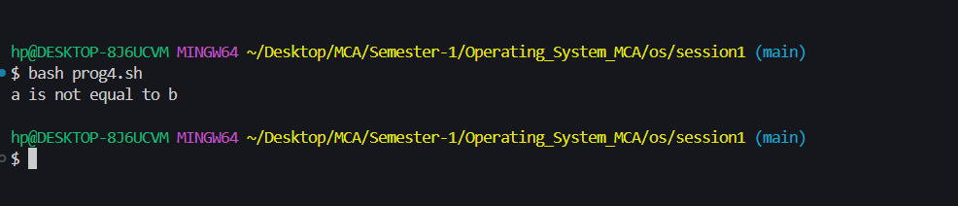

# Q5. Write shell script to take user input and print.

